Connnections Community Church

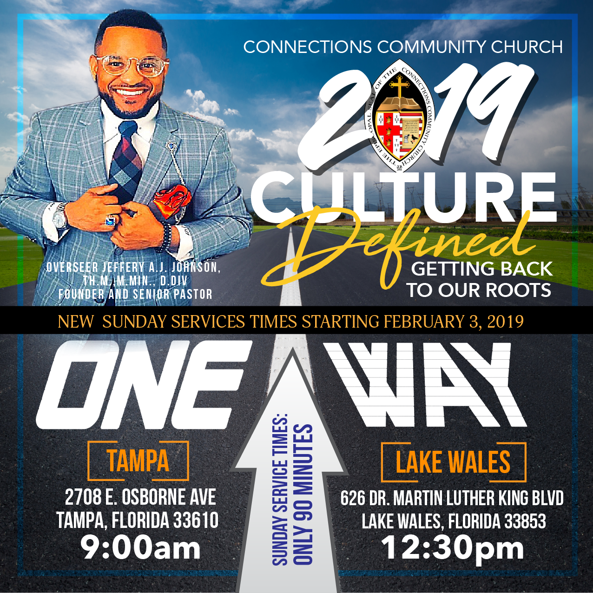

Discovering The Heart God
40 Days of Fasting and Praying

The Very Rev. Dr. Jeffery Alex James Johnson, Senior Pastor/Founder
Lake Wales Campus: 626 Dr. MLK Blvd, Lake Wales, FL 33853
Tampa Campus: 2708 E. Osborne Ave, Tampa, FL 33610
Phone: 813-488-1640
Email: connections3c@gmail.com

www.jajj.org and www.triplecchurch.org
“A COPY WILL BE MADE AVAILABLE ONLINE”

Discovering The Heart God

Suggested Guidelines
- Increase prayer time. Spend at least 2 hours and 30 minutes everyday, praying, reading, and studying God's word, meditating or just being still.
- It is important to drink plenty of REAL cranberry juice on a regular basis, to help flush the kidneys.
- Suggested exercise programs: Daily stretching and deep breathing or walking at least 30 minutes per day, three times a week.
- Limit excessive social telephone calls, secular TV, radio, books, magazines, computer games and video games.
- Exclude and abstain from smoking, drinking, and illegal drugs.
Food For Thought
If you are under a physician’s care, follow his/her instructions.
And, as with all nutritional and exercise programs, it is
Recommended that you consult your physician prior to
Beginning.
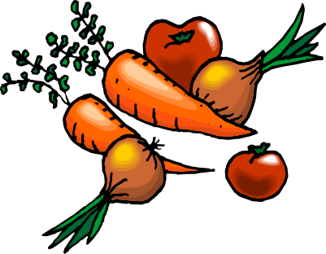
The entire church body of The Connections Community Church, will fast and pray during the Lenten Season. This time of fasting and prayer will begin on Wednesday, March 6, 2019 and will end on Thursday, April 18, 2019. We will fast and petition God concerning our personal spiritual growth, our families and community.
The Holy Spirit, through prayer, will direct your individual time of fasting and abstaining. Fasting is a spiritual discipline that will increase your prayer time, and will also enhance your relationship with God. Fasting is a time of bringing the body under the control of the Holy Spirit on a consistent basis. Instead of receiving physical gratification of food substance and various other activities, we become very aware of the substance and power of the Holy Spirit. As our prayers intensify, God will satisfy our physical and spiritual needs. As we pray, we will become aware of our dependence on God in all areas of our lives, and our relationship with God will strengthen.
Pray and follow the guidelines provided to set your individual time for fasting and prayer.
This is an awesome time of unity and focused prayer in the life of our church and in your spiritual growth and relationship with God.

- Healing: Fasting is a way of cleansing the body so that it can repair. Psalm 139:13-19. ..."l am fearfully and wonderfully made".
- Protection: Refer to Queen Esther in the book of Esther.
- Clarity of God’s Divine Guidance: Daniel fasting gave him wisdom and protection.
- For Missionary Purposes: We will have our own personal testimony after this fast.
- Power: We will have power to overcome overwhelming circumstances. Mark 9:14-29
- Encouragement: To seek to encourage those who are suffering and discouraged.
- Relationships: To seek to strengthen relational skills; e.g. loving, trusting, forgiving, cooperating.
- Giving: To seek Christ’s Spirit of giving in all areas of life and service.
Commitment: The Connections Community Church will fast from Wednesday, March 6, 2019 to Thursday, April 18, 2019. We will eat only seafood, poultry, vegetables, fruits, fruit juices, beans, rice and water during this time period.. NO FRIED FOODS.

Water may have fresh squeezed lemon added. Honey as a staple during biblical times is an acceptable and preferable additive to drinks and food as are any type of herb seasoning. Further information will be given on foods and sample menus. We will learn to be creative in our meal planning. Now, a little about why we fast:

Fasting is an important spiritual concept. There are several reasons for fasting:

Consult with your doctor about your fast, in addition, if you eat as suggested, you should be able to achieve all the necessary nutritional requirements. Please, if you are on medications prescribed by your doctor, continue to take them. A multivitamin is highly recommended. If you are pregnant or have a specific health condition, consult with your doctor. Please don't eat foods you are allergic to!
BEGINNING THE FAST:
Good sources of protein will be in all types of beans and rice and lentils, etc. Shop for numerous vegetables of all kinds. Purchase fruits of all kinds. These will be good for snacks and smoothies. Look at meals consisting of red beans and rice or a large salad with all types of vegetables and olives, and a large fruit smoothie for desert. Oh, don't forget to make that salad dressing from olive oil and fresh squeezed lemon or a
vinegrette, seasoned with God's herbs. What a delight! And above all else, please do not forget to pray and bless each meal that God has so graciously supplied for us!
It is exciting that we as a church family have chosen to be living sacrifices unto God so we can hear God and God can hear us. Fasting is a work of faith. Remember the saying: "Faith without works is dead." Get ready and watch your faith work and move mountains for you and for our church family as a whole. Fasting is a way of humbling ourselves before God. When we humble ourselves to God, we demonstrate faith. Faith is about trusting in God and what we can't see. We have faith, knowing that He will lift us up, bless us and then use us for His divine purposes. We can succeed at this fast because of our love for God. After all, He loved us so much that he gave up His only Son so that we might have life and have it more abundantly.
This is not about losing weight (although it may be a bonus), it is about receiving God's gifts and blessings that He has for us. In every story you read in the Bible related to fasting, ultimately, the people were blessed. The following are just three examples:
1) Jesus fasted for 40 days before facing the devil (Matthew 4:1-11). When Satan tempted Him to make bread out of the stones, Jesus said, "Man shall not live on bread alone, but on every word that proceeds out of the mouth of God"(v.4).
2) Esther, a young Jewish exile, chosen by King Ahasuerus to become queen in the kingdom of Persia, asked the Jewish people to fast and pray, by which the peoples' lives were spared.
3) Daniel and his three friends. Daniel said "Test us for ten days on a diet of vegetables and water. At the end of the ten days, see how we look compared to the other young men who are eating the king's rich food." The results were that God gave them wisdom and knowledge in every branch of literature.
Prepare to be blessed collectively and individually. A suggestion: get a notebook, or piece of paper and write down what your requests are to God and be specific. Put that in an envelope addressed to God. Leave it in His hands.

TYPES OF FAST
There are three types of fast mentioned in the Bible. The Partial Fast or Restricted Fast means to abstain from certain foods and liquids. Daniel 1:8-16 tells the story of Daniel and how he purposed in his heart not to eat meat or drink wine for a certain number of days. This story illustrates the benefits of this type of fast.
The Normal Fast or Natural Fast is the second type of fast in the Bible. This means to abstain from all foods, solids and liquids, except water. Luke 4:1-4, is the story of Christ's fast in the wilderness. Deuteronomy 8:1-3 further emphasizes that the word of God is just as essential as bread (food).
The third type of fast is called the Absolute Fast or Total Fast. Since this involves abstaining from all foods and liquids (including) water, it should never exceed three (3) days and should never be undertaken without a clear command from God. This is the type of fast undertaken by Queen Esther, Mordecai, and other Jews as Esther prepared to approach her husband, King Ahasuerus. In Esther 4:14-16, we see the seriousness of the situation confronting her and sense her commitment to do what was required of her. The ultimate fate of the Jews was at stake.
The following schedule is for the Normal Fast (Juices and Water):
PARISHIONERS DESIGNATED DAY/TIME
A - G Monday, 6:00 AM – 6:00 PM
H - L Tuesday 6:00 AM – 6:00 PM
M- S Wednesday 6:00 AM – 6:00 PM
T - Z Thursday 6:00 AM – 6:00 PM
WHAT IS FASTING?
Fasting is a part of Christian discipline. A disciple of Christ is one who lives the disciplined life. Paul spoke of bringing the body into subjection (1 Cor. 9:27). To fast for spiritual enrichment means to do without food, liquids, or whatever hinders communion with God for a period of time because of a deep concern.
Some fast to pray about specific matters. Others fast merely to adore God in worship. Others fast to meditate on some important problem or decision. Some fast during times of disappointment or tragedy. While some fast in times of need, other fast to give thanks to God for his blessings. When some Christians face great decisions in their lives, they "pray through" decisions without any thought whatsoever of time or food.
Fasting entails forgetting ourselves and letting the Holy Spirit fill us. Fasting will help persons to discover and manage those things that control them, things other than food. By removing nonessentials, balance is restored in our spiritual lives.
The Connections Community Church will observe Partial and Normal Fast concurrently as a corporate body. Beginning Wednesday, March 6, 2019 @ 12:00 P.M. and ending Thursday, April 18, 2019 @ 12:00 P.M. This means all participants will be abstaining from certain foods and liquids throughout the length of the fast (Partial). In addition, on one particular day each week, designated alphabets of last names will limit themselves to only water and juices.
As you begin this fast, ask of God, His guidance and wisdom, His strength and assistance, keeping in mind His Word: "More over, when ye fast, be not as the hypocrites, of a sad countenance; for they disfigured their faces that they may appear unto men to fast.
Verily, I say unto you, they have their reward. But when thou fastest, anoint thy head and wash thy face, that thou appear not unto men to fast, but unto thy Father which is in secret; and thy Father, which seeth in secret shall reward thee openly." Matthew 6:16-18
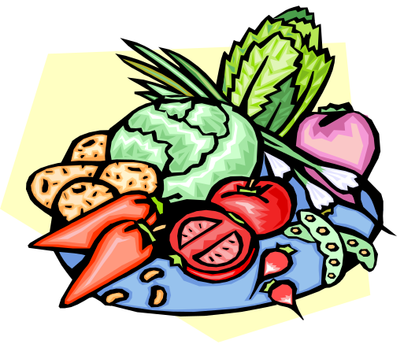

CARBONATED DRINKS, COFFEE, TEA, ETC.

SUGGESTED FOOD FOR DAILY PARTIAL FASTING

FOODS TO EAT FOODS TO ABSTAIN

FRUITS
ALL FRUITS NONE
BREAD
WHOLE WHEAT, RYE, OATS BREAD/CRACKERS MADE WITH WHITE FLOUR
VEGETABLES
ALL VEGETABLES NONE
MEATS
SEAFOOD, POULTRY, BEEF, PORK
BEVERAGES
MILK, FRUIT JUICES, POSTUM
OVALTINES, HERBAL TEAS
DESSERTS
FRUIT CANDY, CAKES, PIES, ICE CREAM, ICE MILK, SHERBERT, ETC
SEASONINGS
BUTTER, HONEY, NO HAM HOCKS, BACON, SALT PORK, ETC., WHITE SUGAR, ARTIFICIAL SWEETENERS
MISCELLANEOUS
BROWN RICE, POPCORN, PASTAS, NO JUNK FOOD
NOODLES, SPAGHETTI, MACARONI
Abstain from fried foods
May God bless you abundantly and keep you!
BROWN SUGAR, HERBS,
LEMON JUICE

All members are urged to take an active part in the Church Fast unless restricted by a physician or a physical condition such as diabetes, pregnancy, cardiac problems, etc.
Be sure to eat three to four small, well balanced meals each day. Do not eat a heavy meal immediately preceding the twenty-four hour fast or immediately following it. Also, plan on “brown bagging” it if it is not possible to purchase the appropriate foods at work or at school.
Again, remember to plan a daily quiet time of at least 2 hours and 30 minutes during each day of the fast. Use this time for praise, prayer and meditation upon God’s Word and goodness. Strive toward a family devotional time at least once each week.
By fasting it is hoped that person will become more receptive to God’s Word, Voice and Spirit; obeying at all times His commands.

SPECIAL REQUESTS

- Each person is to have a prayer partner for the fast period.

- Pray for different concerns/needs from the Prayer Bulletin.

- Concentrate on the DISCIPLINE LIFE.

- Search for and identify areas of Spiritual Growth.

- Pray for the Senior Pastor, his family, the church mission and vision, church finances, and the leadership of the Church.


